**DATA ANONYMIZATION PIPELINE**

**A PROJECT REPORT**

*Submitted by*

**MODI SHRESHTHA P**

**190130111081**

***In partial fulfilment for the award of the degree of***

**BACHELOR OF ENGINEERING**

***In***

**Electronics and Communication Engineering**

**GOVERNMENT ENGINEERING COLLEGE**

**GANDHINAGAR**

**Gujarat Technological University, Ahmedabad**

**May, 2023**





**GOVERNMENT ENGINEERING COLLEGE GANDHINAGAR**

**CERTIFICATE**

This is to certify that the project report submitted along with the project entitled **Data Anonymization Pipeline** has been carried out by **Modi Shreshtha P** under my guidance in partial fulfilment for the degree of Bachelor of Engineering in Electronics and Communication, 8th Semester of Gujarat Technological University, Ahmedabad during the academic year 2022-23.

Mr Himanshu Nayak Prof. Tejaskumar Sheth

Internal Guide Head of the Department



**GOVERNMENT ENGINEERING COLLEGE GANDHINAGAR**

**DECLARATION**

We hereby declare that the Internship/ Project report submitted along with the Internship/Project entitled **Data Anonymization Pipeline** Submitted in partial fulfillment for the degree of Bachelor of Engineering in E**lectronics And Communication** to Gujarat Technological University, Ahmedabad, is a bonafide record of original project work carried out by me at GEC Gandhinagar. Under the supervision of **Prof. Himanshu Nayak** and that no Part of this report has been directly copied from any students reports or taken from any other source, without providing due reference.

Shreshtha Modi

**ACKNOWLEDGEMENT**

Firstly, I would like to thank **Mr Nirav Shah.** at **Eternal soft solutions** for giving me the opportunity to intern and learn at his organization. During my tenure at Eternal, I learnt a lot of invaluable technical and interpersonal skills

I am highly indebted to my faculty guide **Mr Himanshu Nayak** for his constant guidance and support throughout the internship and **Mr Tejas Sheth.** (Head of Department, Government Engineering College Gandhinagar) for his constructive criticism and mentorship throughout the internship

My sincere thanks to ***Dr Shweta Dave*** (Principal, Government Engineering College Gandhinagar) and the entire staff of Government Engineering College Gandhinagar for giving me the opportunity to intern at an organization and learn and for creating a holistic environment where I was able to learn and grow.

Lastly, I want to thank all my friends and colleagues who challenged me to push my limits and helped me with all of my queries. I would also like to thank all the researchers and open source developers for their efforts in crafting products that I could build upon and products which continue to help a lot of people all around the world

Modi Shreshtha Pragnesh

190130111081

* bly
* Firmware Development
* Embedded/IOT Product Development
* Smart Home /Garden/Agricultural

Product Development

* Hardware Integration

1. **Engineering Automation**

* Design Automation
* CAD Customization
* Process Automation

1. **Building Design Service**

* Architectural BIM Services
* Structural BIM Services
* Scan to BIM Services
* MEP BIM Services
* Interdisciplinary Clash Coordination
* 3D Modelling and Rendering services

1. **Creative Services**

* Rendering and Animation
* AR/VR Development
* Digital Marketing
* Branding

**Products**

| 1. [Inventor Quantity Tool](https://www.monarch-innovation.com/product/quantity-tool) | 1. [Solid edge Rename Tool](https://www.monarch-innovation.com/product/rename-tool) | [Inventor Print Manager](https://www.monarch-innovation.com/product/print-manager) |
| --- | --- | --- |
| 1. [Autodesk Inventor Tool Suite](https://www.monarch-innovation.com/product/autodesk-inventor-tool-suite) | 1. [Inventor Save Scheduler](https://www.monarch-innovation.com/product/save-scheduler) | [Inventor Sharp Corner Remover](https://www.monarch-innovation.com/product/sharp-corner-remover) |

* 1. **Organization chart**

**1.4 Capacity of plant**

Monarch innovation plant capacity is 250 People in shift order. Monarch innovation Pvt Ltd is proud to “Work-certified” for the second Consecutive year**.**

Great Place to work certified SEPT 2022 – SEPT 2023 India

Great Place to work certified JUL 2021-Jul 2022 India

Fig. 1.3 Great place to work



Fig. 1.4 Great place to work

**Chapter 2**

1. **Overview of different department**

**2.1 It includes the details about the work being carried out in each department:**

In Monarch innovation have a different department and they list is given below.

1. R&D department
2. IT department
3. Mechanical department
4. BIM department

1. **R&D department:** In a R&D department we are work with Embedded and IOT Service. n today’s technology-driven world various industries ranging from consumer electronics, office automation, home automation, transportation, telecommunication & even aeronautics make use of embedded systems to control automation systems.

* Such Embedded Systems connect together and form an “Internet of Things”, IoT, that makes the exchange of data between devices possible.
* Monarch Innovation helps you build complex and customized embedded products by utilizing unique Hardware & Software Designs. Our area of expertise lies in designing & developing IoT embedded systems and embedded software.

1. **IT department:** IT Solutions & Services that provide access to advanced technologies and time-tested practices throughout the entire IT process.

* Monarch Innovation is an IT services company providing innovative and reliable solutions that rapidly increases your company’s future growth.
* We develop unique IT infrastructure solutions and support services, including application and security services for both cloud and traditional technologies, topped off with our collective business, technical and industry expertise.
* Being an IT services provider, we provide tailored IT consulting services and IT Support to organizations of any size and type. We undertake projects of varying requirements and scales, from [web development](https://www.monarch-innovation.com/web-development/) to [mobile app development](https://www.monarch-innovation.com/mobile-development/) to Cloud Apps. We have it all covered for you.

1. **Mechanical Department:** Monarch Innovation’s mechanical engineering services consist of a vast range of [engineering solutions](https://www.monarch-innovation.com/) , including drawing, design, graphics, animation, and CAD-related services to align with the needs of our clients.

* Our Mechanical Engineering Services benefit clients by calculating the space and durability of equipment, aligning test specifications with project blueprints, testing individual tools and parts, and making modifications based on the results of testing.
* Furthermore, we provide detailed blueprints, evaluate sketches & designs, and guide you through every step of your project till completion.
* Our mechanical design services include converting sketches to 2D & 3D CAD Modelling, developing 2D drafts for fabrication, installation & assemblies, Machine & Tool design, Design & specification of material handling equipment, Cooling & Ventilation Systems Design, Piping Design, and Stress Analysis**.**

1. **BIM department:** 3D BIM Modelling has transformed the AEC Industry. Partner’s name, being a specialized BIM outsourcing company, offers customized [3D BIM Modelling](https://www.monarch-innovation.com/3d-modelling-and-rendering-services/), 4D, and 5D BIM modelling to all the stakeholders.

* We deliver [BIM Modelling services](https://www.monarch-innovation.com/architectural-bim-services/) to construction companies for enhanced coordination between engineers, architects, and designers, contractors, consultants, etc. Monarch Innovation being a leading BIM solution company, we enable better collaboration and execution of projects by creating 3D models for building construction projects.
* We provide 3D models using Revit that have significantly transformed project estimation, quality control issues, scheduling, and streamlined different processes of construction successfully.
* Monarch’s 3D BIM model displays every feature of the project effectively and clearly that has always been a limitation with conventional paper and 2D designs. BIM covers floor plans, elevations, and [3D modelling services](https://www.monarch-innovation.com/3d-modelling-and-rendering-services/).
* The entire design of BIM can be seen even before starting the construction and has an effective architectural visualization. BIM increases the accessibility of your team to review and mark up the design thereby ensuring teamwork coordination and synchronization.

**2.2 LIST THE TECHNICAL SPECIFICATIONS OF MAJOR EQUIPMENT USED IN EACH DEPARTMENT**:

1. **Multimeter**: A digital multimeter is a test tool used to measure two or more electronics values—principally voltage (volts), current (amps) and resistance (ohms). It is a standard diagnostic tool for technicians in the electronics /electronic industries**.**
2. **DSO**: A digital storage oscilloscope (DSO) is an electronic instrument that measures and records electronics signals. It converts the analog signal into a digital format and stores it in its digital memory, allowing for easy recall and analysis. Digital storage oscilloscopes are used in a variety of applications.
3. **Microcontroller:** Microcontrollers are used in automatically controlled products and devices, such as automobile engine control systems, implantable medical devices, remote controls, office machines, appliances, power tools, toys and other embedded systems.
4. **Electronics component:** Microcontrollers are used in automatically controlled products and devices, such as automobile engine control systems, implantable medical devices, remote controls, office machines, appliances, power tools, toys and other embedded systems**.**
5. **PCB Design software:** PCB design software aids electronic engineers in designing layouts for printed circuit boards. Engineers leverage the software to collaborate on the design process, pull previously used circuit board component designs from PCB libraries, and verify circuit schematic designs.
6. **Solder iron:** A soldering iron is a hand tool used to heat solder, usually from an electronics supply at high temperatures above the melting point of the metal alloy. This allows for the solder to flow between the workpieces needing to be joined.
7. Precision hand tool: Precision hand tools including tweezers, wire cutters, vacuum pick-up pens, vacuum pump systems, diamond scribes, and micro mini tools.

**2.3 PREPARE SCHEMATIC LAYOUT WHICH SHOWS THE SEQUENCE OF OPERATION FOR MANUFACTURING OF END PRODUCT**:

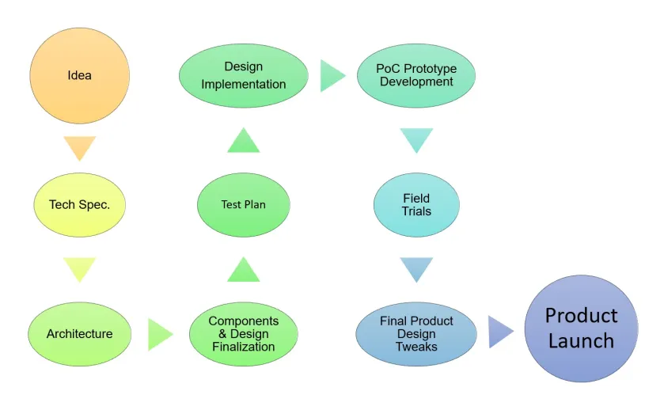

Fig. 2.1 Manufacturing Product

**2.4 Explain in details about each stage of production**

* **Ideation: -**

This is the stage where an idea is discussed with all the stakeholders and brain-stormed to conclude if the idea is worth taking to the development stage.

Market data is collected from online research, interviews with potential customers, prospects, other people facing market to make a case with two important points:

Problemsthe product will solve. All features of the products could be segmented into urgent needs, good to have and luxury. More you are solving urgent needs better the response from the market would be for the product.

* **Technical Specification: -**

A detailed technical design requirement specification document should be created. Product spec should cover the main things like the purpose of the product, block diagram, main features, environmental conditions, manufacturing requirements, etc.

* **Architecting the Solution: -**

After finalizing a detailed technical specification document, it’s time to architect the solution. On a high level, how the design will look like, what are strategies you will use to build a solution, which type of power supply, which type of wired or wireless connectivity you will use, how the firmware design will look like, Mobile App/PC software/cloud-based application design needs to be decided.

For the hardware design part, this forms the basis for the next step which is selecting the appropriate component for each block or part of the circuit based on various critical parameters like quality, size, features, cost, lead time, EOL, etc.

* **Component Selection & Design Finalization: -**

Once the architecture is done, engineers need to look at each block in the system and select the components and finalize the design (application circuit).

An engineer in this stage will decide, for example, a power supply which type of power supply needs to be designed like using a linear regulator or using a DC-DC switching converter or with something else and then which power chip need to used and its application circuit, everything is decided here.

* **Creating a Test Plan: -**

Hardware & Software Testing is very important to check the reliability of the product. Customers pay for the working products and get frustrated with the product which does not meet the expectation or fail in the field.

Companies spend a huge amount of time testing their products so that their customer does not experience any issues. See this video, how mobile is getting tested for hours and days to check its reliability.

For any embedded product, you need to define a proper testing plan, it should cover the following:

* Hardware design validation
* Software design validation
* Production level product testing
* **Design Implementation: Hardware, Firmware, software, Enclosure Design: -**

This is the core engineering stage of the implementation. Here the architecture is converted into the design. For hardware: schematic capture, PCB layout will be done. MCU firmware & if any software is required will be developed. Enclosure design work will also come into this stage.

A necessary review system needs to be put in place to ensure first time right is developed. If an external consultant is required for the design reviews, one should not hesitate, most of the time it’s worth the investment.

* **Proof of Concept, Prototype Development & Testing: -**

If the design is completely new or if you don’t have the confidence on the full-design or a part of the design, it is a good idea to build the prototype first to prove the design and while doing so see if there are any issues.

Sometimes buying readily available block level modules (power supply, MCU, Wireless modules, etc.) and connecting them to form a system, writing a basic firmware and testing in a simulated environment helps gain initial confidence on the design’s performance. This could save a huge amount of money, effort and time otherwise might get wasted if a respin of the design is required due to some issues. Once this is proven, you can build the prototype and test it again for the functionality & the environmental conditions.

* **Field Trials: -**

You might have heard engineers saying that their product works well in their lab but has issues in the field.

Field conditions are different, engineers need to think through what all conditions their product will go through in the field so that they can reproduce those conditions and check the performance of their product even before sending their product out in the field. Not only field conditions but the user is also different. Engineers need to think of how a layman will handle their product in the field.

* **Final Product Improvements: -**

After field trials are done for several weeks and months, all the improvement needs to be incorporated in the design based on the feedback.

If during field trials some issues are found, you will need to also improve the test procedures you follow during the design validation/ production testing stage to ensure a flawless product comes out of production.

* **Product Launch: -**

Before launching the product, several other things need to be put in place other than the product itself like:

* Various product certifications based on features it has and the countries it will be sold in.
* Documentation: Product page on the website, Quick introduction video, Datasheet, User guide, Setting up the Support channel, etc

**Chapter 3**

1. **Introduction to Project / Internship and Project / Internship Management**

**3.1 INTERNSHIP SUMMARY**

An internship focused on lithium-ion battery charger would likely involve working with a team of professionals to develop, test, and refine the design of the charger. The internship might include a range of activities such as:

1. Designing and prototyping circuits: This could involve working with a team of electronics engineers to design circuits for the lithium-ion battery charger. You may work with simulation software to test and optimize the circuits before building physical prototypes.

2. Testing and troubleshooting: During the internship, you may work on testing the charger prototypes to identify any issues or areas for improvement. You might use tools like oscilloscopes, power analysers, and multimeters to collect data and analyze performance.

3. Documentation and reporting: You may be responsible for documenting your work and presenting your findings to your team and other stakeholders. This could include writing reports, creating presentations, and contributing to technical documentation.

4. Collaboration: Working on a lithium-ion battery charger would likely require close collaboration with a team of engineers, product managers, and other professionals. You may participate in team meetings, provide feedback on other team members' work, and collaborate on design decisions.

Overall, an internship focused on lithium-ion battery chargers would provide valuable experience in electronics engineering, circuit design, testing and prototyping, an d collaboration.

**3.2 PURPOSE**

The purpose of a lithium-ion battery charger is to recharge lithium-ion batteries, which are commonly used in a wide range of electronic devices, including smartphones, laptops, and electric vehicles. Lithium-ion batteries are rechargeable and have become increasingly popular due to their high energy density, long lifespan, and low self-discharge rate.

The charger is responsible for providing the correct amount and type of energy to the battery, ensuring that it is charged safely and efficiently. Most lithium-ion battery chargers use a constant current-constant voltage (CC-CV) charging algorithm, which involves charging the battery at a constant current until it reaches a certain voltage, then maintaining that voltage until the battery is fully charged.

Some lithium-ion battery chargers are designed for specific applications, such as charging electric vehicle batteries, and may incorporate additional features like thermal management systems to ensure safe operation. Overall, the purpose of a lithium-ion battery charger is to provide a convenient and reliable way to recharge the batteries that power our electronic devices.

* 1. **OBJECTIVE**

1. Efficient charging: The objective of a lithium-ion battery charger is to recharge batteries safely and efficiently. Therefore, one objective could be to design a charger that charges the battery as quickly and efficiently as possible while minimizing heat generation and avoiding overcharging.
2. Compatibility: Another objective of developing a lithium-ion battery charger is to ensure compatibility with various devices that use lithium-ion batteries. This means designing the charger to work with different battery chemistries and sizes, as well as ensuring compatibility with various electronic devices.
3. Safety: Safety is a top priority when it comes to developing lithium-ion battery chargers. Therefore, the objective would be to design a charger that incorporates features like overcharge protection, short-circuit protection, and thermal protection to prevent accidents and ensure safe operation.
4. User-friendliness: The objective of developing a lithium-ion battery charger is to make it easy for users to charge their devices. This means designing a charger that is simple to use, with clear instructions, and possibly incorporating features like LED indicators to show the charging status.
5. Cost-effectiveness: Finally, an objective of developing a lithium-ion battery charger could be to make it cost-effective to manufacture and sell. This could involve designing a charger that uses affordable components and materials, as well as minimizing the need for expensive or complex manufacturing processes.
   1. **SCOPE**

Research and development: This could involve conducting research on the latest developments in lithium-ion battery technology and charger design, as well as developing new charging algorithms and circuit designs.

Prototyping: Once a design has been developed, prototyping is necessary to test and refine the design. This could involve building multiple prototypes and testing them under various conditions to ensure they meet the desired specifications.

Testing and validation: After the prototypes have been built, the next step is to test and validate the performance of the chargers. This could involve testing for factors like efficiency, compatibility, and safety.

Manufacturing and production: Once the charger design has been validated, the next step would be to manufacture and produce the chargers for commercial use. This could involve sourcing components and materials, designing manufacturing processes, and testing and validating the production process.

Quality control and customer support: Once the chargers are being produced and sold, it is important to ensure they meet the desired quality standards and to provide customer support in case of any issues or questions.

* 1. **Technology and Literature Review**

A technology and literature review is a comprehensive analysis of existing research and development in a particular field or industry. In the context of lithium-ion battery chargers, a technology and literature review could involve examining existing research and development related to the design, development, and production of lithium-ion battery chargers. This would include an analysis of existing patents, research papers, industry publications, and other sources of information related to the field.

The technology review would focus on the specific technologies used in lithium-ion battery chargers, including the types of circuits and charging algorithms used. This would also include an examination of the latest advancements in battery technology, as well as any emerging technologies that may impact the design and development of lithium-ion battery chargers.

The literature review would involve an analysis of the existing research related to lithium-ion battery chargers, including the latest research papers and industry publications. This would involve a review of the latest research related to efficiency, safety, and compatibility of lithium-ion battery chargers, as well as any new techniques or methods for improving the charging performance of these devices.

Together, the technology and literature review would provide a comprehensive overview of the current state of lithium-ion battery charger technology, as well as any emerging trends or developments in the field. This information can be used to inform the design and development of new lithium-ion battery chargers, and can help to identify areas for future research and development.

* 1. **Project / Internship Planning**

For a successful software project. The following steps can be followed:

● Select a project

○ Identifying project's aims and objectives

○ Understanding requirements and specification

○ Methods of analysis, design and implementation

○ Testing techniques

○ Documentation

● Project milestones and deliverables

● Budget allocation

○ Exceeding limits within control

● Project Estimates

○ Cost

○ Time

○ Size of code

○ Duration

● Resource Allocation

○ Hardware

○ Software

○ Previous relevant project information

**3.6.1 Project / Internship Development Approach and Justification**

Approach: - Top-Down Approach

I have use Top-Down Approach. When approaching a project from the top down, higherlevel decision-makers start with a big picture goal and work backward to determine what actions different groups and individuals will need to take in order to reach that goal.

**3.6.2 Project / Internship Effort and Time, Cost Estimation**

Our internship is based on lithium ion battery charger and they project is are not done on final stage still our R&D is running on lithium ion battery charger so we cannot provide exact time and cost estimation for this project.

**3.6.3 Roles and Responsibilities**

∙ Oversee high-level project progress.

∙ Provide input to and approval of the project charter.

∙ Provide and approve project budget and resources.

∙Approve any project change requests.

∙Provide exposure and buy-in from senior management.

∙ Approve the project completion.

**3.6.4 Group Dependencies**

Group dependencies may include:

1. Task dependencies: Tasks that are dependent on each other, where one task must be completed before the next task can begin. For example, the research and development team may need to complete the design of the charger before the prototyping team can begin building the prototype.
2. Resource dependencies: Dependencies on specific resources, such as equipment, materials, or software. For example, the prototyping team may need access to specialized equipment or materials that are controlled by another team or department.
3. Schedule dependencies: Dependencies on specific timelines or deadlines. For example, the manufacturing team may need to receive the final design specifications by a certain date in order to begin the production process on schedule.
4. Communication dependencies: Dependencies on effective communication between teams or departments. For example, the testing team may need to communicate test results and feedback to the research and development team in order to inform design improvements.

Effective management of group dependencies is essential for ensuring that the project is completed on time and within budget. This may involve establishing clear communication channels, developing contingency plans for potential delays or obstacles, and coordinating efforts between different teams or departments.

* 1. **Project / Internship Scheduling (Gantt Chart/PERT/Network Chart)**

● An elementary Gantt chart or Timeline chart for the development plan is given below.

● The plan explains the tasks versus the time (in weeks) they will take to complete.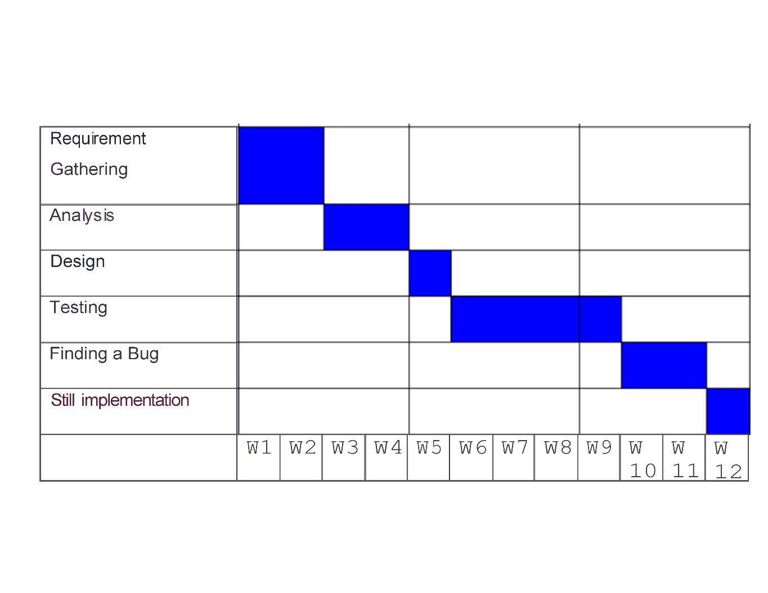

Fig 3.1 Internship Scheduling

**Chapter 4**

* 1. **System Analysis**
  2. **Study of Current System**

The Use Case diagram models the users' expectation for using the system. The people and systems that interact with the target system are called actors. The features other system that the actors use is called use cases. Some use cases interact with other use cases, a relationship modelled using dependency arrows. The goal of the Use Case diagram is to identify all the features that the clients expect the system to support, but it does not reveal any details about the implementation of these features. Use cases can be written several ways but the most common is to represent a view of the system from outside the system.

* Use Case diagrams are valuable because they Identify the clients' expectations for the system.
* Identify specific features of the system.
* Identify shared behaviour among system features.
* Provide a simple and easily understood way for clients to view their requirements.
  1. **Problem and Weaknesses of Current System**

Slow charging speed: The charging dock in the current system has a low output, which results in slow charging of the device.

Short charging cable: The charging cable in the current system is not long enough, which restricts the user's freedom of movement while the device is charging.

Limited compatibility: The current system may not be compatible with a range of devices, which limits its usefulness.

Safety concerns: The current system may not have adequate safety measures in place, which may lead to overcharging, overheating, and short-circuiting.

Inefficient design: The current system may not be designed in the most efficient manner, which may lead to wasted energy and increased costs.

* 1. **Requirements of New System**

1. Input voltage and current range: The new charger should be capable of charging lithium-ion batteries within a specified input voltage and current range, as per the battery specifications.
2. Charging time: The new charger should be capable of charging the lithium-ion battery within a specific time frame, which should be faster than the current system.
3. Charging current and voltage control: The new charger should have the ability to control charging current and voltage, which should help to prevent overcharging and overheating.
4. Compatibility: The new charger should be compatible with a range of lithium-ion battery types and sizes.
5. Safety: The new charger should be designed with safety in mind, including protection against overcharging, overheating, and short-circuiting.
6. Efficiency: The new charger should be designed to be energy-efficient, which should reduce electricity consumption and operating costs.
7. Cost-effective: The new charger should be cost-effective to produce, which will enable the company to offer it at a competitive price point.
8. User-friendly: The new charger should be easy to use, with a simple and intuitive interface.
9. Durability: The new charger should be built to last, with a durable and reliable design.
   1. **System Feasibility**

* Form a project team and appoint a project leader.
* Develop system flowcharts.
* Identify the deficiencies of current system and set goals.
* Enumerate the alternative solution or potential candidate system to meet goals.
* Determine the feasibility of each alternative such as technical feasibility, operational feasibility, etc.
* Weight the performance and cost effectiveness of each candidate system.
* Rank the other alternatives and select the best candidate system.
* Prepare a system proposal of final project directive to management for approval.
  + 1. **Does the system contribute to the overall objectives of the organization?**

The new lithium-ion battery charger system can contribute to the overall objectives of the organization. By providing a more efficient, safe, and convenient charging experience for users, the new system can help to improve customer satisfaction, which can lead to increased sales and revenue for the organization. Additionally, by incorporating energy-efficient and cost-effective design features, the new system can help to reduce operating costs and improve the organization's bottom line. Overall, the new system can help the organization to achieve its objectives of providing high-quality products and services to its customers while also achieving its financial goals.

* + 1. **Can the system be implemented using the current technology and within the given cost and schedule constraints?**

It's difficult to say definitively without more information about the specific technology and cost and schedule constraints for the lithium-ion battery charger project. However, if the requirements for the new system are feasible with the current technology, and the cost and schedule constraints have been carefully considered and planned for, then it may be possible to implement the system within those constraints.

To ensure that the new system can be implemented within the given constraints, the project team should conduct a thorough feasibility analysis, which should include assessing the available technology and materials, estimating the costs of development and production, and creating a detailed project schedule that takes into account potential risks and delays. The project team should also be prepared to adjust the scope of the project or make other modifications as necessary to stay within the given constraints.

Overall, implementing the new system within the given technology, cost, and schedule constraints will require careful planning, attention to detail, and a willingness to be flexible and adapt as necessary to overcome any challenges that may arise during the development and production process.

**4.4.3 Can the system be integrated with other systems which are already in place?**

Yes, it is possible for the new lithium-ion battery charger system to be integrated with other systems that are already in place, provided that the necessary interfaces and protocols are supported by both the new and existing systems.

Before integration can take place, it's important to first identify any existing systems that the new lithium-ion battery charger will need to interface with, and to understand the specific protocols and data formats used by those systems. Once these requirements have been identified, the project team can work to ensure that the new system is designed to support those interfaces and protocols, and to create any necessary middleware or adapters that will enable the new system to communicate effectively with the existing systems.

* 1. **Activity / Process in New System / Proposed System**

1. User authentication: Before using the battery charger, the user must first authenticate themselves to the system, either by entering a password or using biometric authentication.
2. Battery status check: The system checks the status of the battery to ensure that it is compatible with the charger and that it is safe to charge.
3. Charging configuration: The user selects the charging configuration, such as fast charging or slow charging, and the system adjusts the charging parameters accordingly.
4. Charging process: The system begins the charging process, monitoring the battery's temperature and voltage to ensure that it remains within safe limits.
5. Charging completion: Once the battery is fully charged, the system notifies the user and automatically stops the charging process.
6. Charging history tracking: The system records information about each charging session, including the time, date, charging configuration, and any errors or warnings that occurred during the session.
7. System maintenance: The system performs regular maintenance tasks, such as software updates and system diagnostics, to ensure that it continues to operate reliably and efficiently.
8. System security: The system includes robust security features, such as encryption and firewalls, to protect against unauthorized access and data breaches.

**4.6 Features of New System / Proposed System**

1. Multiple charging configurations: The system should be able to support different charging configurations, such as fast charging or slow charging, depending on the user's needs and the battery's specifications.
2. Intelligent charging: The system should be able to adjust the charging parameters dynamically based on the battery's current status and conditions, in order to optimize the charging process and ensure that the battery is charged as quickly and efficiently as possible.
3. Safety features: The system should include a range of safety features, such as over-voltage protection, over-current protection, and temperature monitoring, to prevent damage to the battery or other components.
4. User interface: The system should have a user-friendly interface that allows users to easily select the charging configuration and monitor the charging process.
5. Charging history tracking: The system should record information about each charging session, including the time, date, charging configuration, and any errors or warnings that occurred during the session, to enable tracking and analysis of charging patterns over time.
6. Compatibility: The system should be designed to be compatible with a wide range of battery types and charging protocols, in order to maximize its usefulness and appeal to a broad range of users.
7. Energy efficiency: The system should be designed to be as energy-efficient as possible, in order to minimize the amount of energy consumed during the charging process and reduce the environmental impact of the system.
8. Security: The system should include robust security features, such as encryption and firewalls, to protect against unauthorized access and data breaches.

**4.7 List Main Modules / Components / Processes / Techniques of New System / Proposed System**

1. User authentication module: This module would be responsible for authenticating users before they can use the battery charger. It could use various techniques, such as password authentication or biometric authentication.
2. Charging configuration module: This module would allow users to select the desired charging configuration, such as fast charging or slow charging, and would adjust the charging parameters accordingly.
3. Charging control module: This module would be responsible for controlling the charging process, monitoring the battery's status, adjusting the charging parameters dynamically, and ensuring that the charging process is safe and efficient.
4. Charging history tracking module: This module would be responsible for recording information about each charging session, including the time, date, charging configuration, and any errors or warnings that occurred during the session.
5. Compatibility module: This module would ensure that the system is compatible with a wide range of battery types and charging protocols, in order to maximize its usefulness and appeal to a broad range of users.
6. Safety module: This module would include various safety features, such as over-voltage protection, over-current protection, and temperature monitoring, to prevent damage to the battery or other components.
7. User interface module: This module would provide a user-friendly interface that allows users to easily select the charging configuration, monitor the charging process, and view charging history.

**4.8 Selection of Hardware / Software / Algorithms / Methodology / Techniques / Approaches and Justification**

**Hardware:**

* Microcontroller: A microcontroller could be used to control and monitor the charging process. Some popular options are Arduino, Raspberry Pi, and STM32. The selection would depend on the specific requirements of the system.
* Charging Circuit: A charging circuit is required to convert AC to DC and regulate the charging process. There are various off-the-shelf charging circuits available, such as the TP4056 or the BQ24296. The selection would depend on the battery type, capacity, and charging specifications.

**Software**:

* Programming Language: Depending on the microcontroller selected, the programming language could be C, C++, Python, or other languages supported by the microcontroller.
* User Interface: A graphical user interface (GUI) could be developed using frameworks such as Qt or Tkinter to allow users to interact with the system and monitor the charging process.

**Algorithms:**

* Battery Charging Algorithm: The algorithm used for charging the battery could be based on various techniques such as Constant Current (CC), Constant Voltage (CV), or a combination of both. The algorithm would depend on the battery type, capacity, and charging specifications.

**Methodology:**

* Agile Methodology: Agile methodology could be used to develop the system in an iterative and incremental manner, allowing for quick feedback and adaptation to changes in requirements.

**Techniques**:

* Rapid Prototyping: Rapid prototyping techniques could be used to quickly test and validate different hardware and software configurations, allowing for faster iteration and refinement of the system.

**Approaches**:

* Modular Approach: A modular approach could be used to design the system, allowing for easier maintenance and scalability as new features or hardware components are added to the system.

**Chapter 5**

* 1. **System Design**
  2. **System Design & Methodology**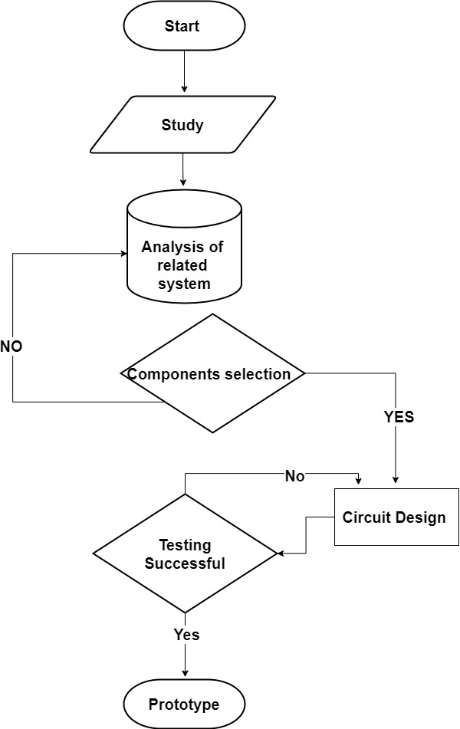

Fig 5.1 flow chart of design methodology

* 1. **Circuit Design**

Given below circuit design is for reference purpose because our company not allowed to share data related to work.

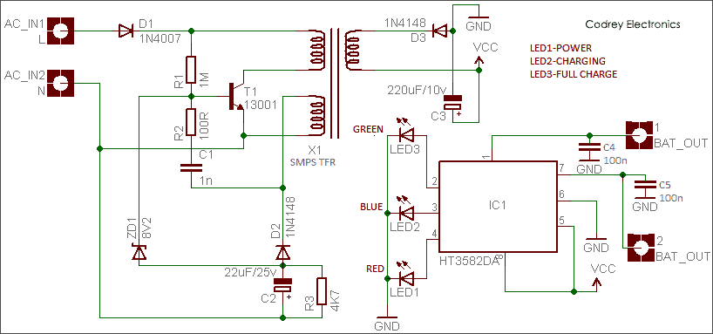

Fig 5.2 circuit design

* 1. **Input / Output and Interface Design**

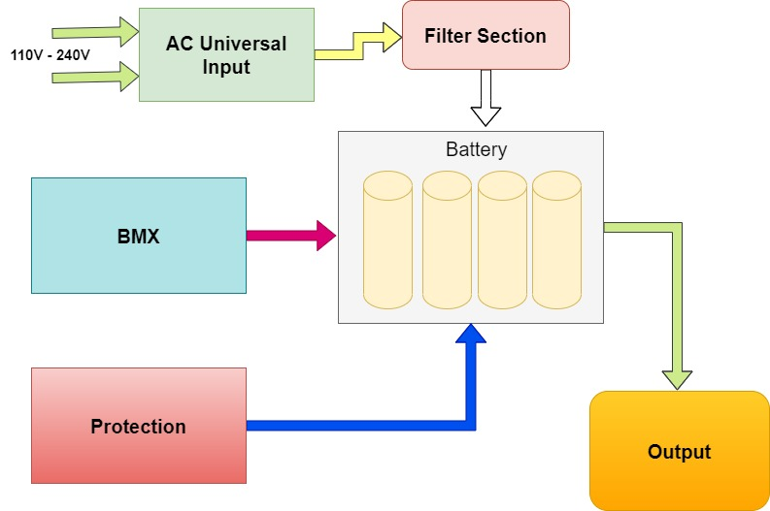

Fig 5.3 Input output interface

**Chapter 6**

* 1. **Implementation**
  2. **Implementation Platform / Environment**

1. Microcontroller-based platform: A microcontroller-based platform such as Arduino or Raspberry Pi can be used to implement the control and monitoring of the charging process. These platforms have a low cost and are easy to program and interface with other components.
2. Dedicated battery management IC (Integrated Circuit): Many battery management ICs are available in the market that provides various features such as charging and discharging control, overvoltage/undervoltage protection, temperature sensing, etc. These ICs can be integrated with a microcontroller or other computing devices to implement a lithium-ion battery charger.
3. Custom hardware design: In some cases, a custom hardware design may be required to meet specific requirements. In this case, a PCB (Printed Circuit Board) can be designed and fabricated, which includes all the necessary components such as voltage regulators, current sensors, temperature sensors, etc.
4. Mobile app: Many lithium-ion battery chargers come with a mobile app that can be used to monitor and control the charging process. The app can communicate with the charger using Bluetooth or Wi-Fi and can provide real-time data such as battery status, charging current, charging time, etc.

**6.2 Process**

1. Charging process: The charging process should be designed to ensure that the battery is charged safely and efficiently. The charger should include a charging controller that regulates the charging current and voltage to prevent overcharging, overheating, and damage to the battery.
2. Charging algorithm: The charging algorithm is a critical component of the charger and determines the charging current and voltage based on the battery's characteristics. The algorithm should be designed to optimize the charging time and maximize the battery's lifespan.
3. Temperature sensing: Lithium-ion batteries can be sensitive to temperature, and overheating can lead to reduced battery life and safety issues. The charger should include a temperature sensor that monitors the battery's temperature and adjusts the charging current and voltage accordingly.
4. User interface: The user interface should be designed to make it easy for users to operate the charger and monitor the charging process. It should include an LCD display that shows the battery status, charging current, voltage, and time remaining.
5. Protection circuitry: The charger should include protection circuitry to prevent overcharging, over-discharging, and short-circuiting of the battery. This can include overvoltage protection, undervoltage protection, and overcurrent protection.
6. Communication interface: The charger can include a communication interface such as USB, Wi-Fi, or Bluetooth to communicate with other devices such as smartphones or laptops. This can enable users to monitor the charging process remotely and receive notifications when the charging is complete.
7. Power supply: The charger should include a stable and reliable power supply that can provide the necessary voltage and current to charge the battery. This can include a switching power supply or a linear power supply.
8. Power management: The charger should include power management modules such as voltage regulators and current sensors to ensure that the charger operates efficiently and effectively.
9. Safety certifications: The charger should comply with safety certifications such as CE, FCC, and UL to ensure that it meets safety standards and regulations.

**6.3 Results / Outcomes**

1. System Performance: The performance of the system can be evaluated based on the charging time, charging efficiency, and accuracy of the charging algorithm.
2. User Experience: The user experience of the system can be evaluated based on the ease of use, user interface design, and overall user satisfaction.
3. Cost-Effectiveness: The cost-effectiveness of the system can be evaluated based on the total cost of development, including hardware, software, and testing, compared to the benefits and value provided by the system.
4. Scalability: The scalability of the system can be evaluated based on its ability to handle larger battery sizes and charging loads.
5. Reliability: The reliability of the system can be evaluated based on its ability to function correctly over time and in different environments.

**6.4 Result Analysis**

The system's performance can be analysed by comparing the charging time and efficiency of the lithium-ion battery charger against industry standards and benchmarks. Any deviation from the expected performance can be investigated and analysed for improvements.

The user experience of the system can be analysed through user feedback and surveys, which can provide insights into the ease of use, user interface design, and overall user satisfaction. Any feedback received can be analysed for improvements to the user experience.

The cost-effectiveness of the system can be analysed by comparing the total cost of development against the benefits and value provided by the system. The cost-effectiveness can be improved by optimizing the hardware and software components, reducing the testing time, and minimizing the overall development cost.

Scalability and reliability of the system can be analysed by testing the system under different loads and environments. The system should be able to handle larger battery sizes and charging loads while still maintaining its efficiency and reliability.

Deliberations can be done on the overall system design, methodology, and approach used for developing the lithium-ion battery charger system. Any issues or problems that arose during the development process can be identified and analysed for improvements in future projects.

Overall, result analysis, comparison, and deliberations can help identify areas for improvement and provide insights into the system's performance, user experience, cost-effectiveness, scalability, and reliability.

**Chapter 7**

* 1. **Testing**
  2. **Testing Plan / Strategy**
* Test objectives: The objectives of the testing plan/strategy should be defined, outlining the goals and expected outcomes of the testing process.
* Test scope: The scope of the testing plan/strategy should be defined, outlining what will be tested, what will not be tested, and any limitations.
* Test approach: The approach for testing should be defined, including any test methodologies, techniques, tools, and resources to be used.
* Test environment: The environment for testing should be defined, outlining the hardware and software components, configurations, and settings required for testing.
* Test scenarios: Test scenarios should be defined, outlining the specific test cases that will be executed to verify the system's functionality, performance, and reliability.
* Test data: The test data should be defined, including any test scripts, data sets, or other input required for testing.
* Test schedule: The schedule for testing should be defined, outlining the timeline, milestones, and deliverables for the testing process.
* Test team: The testing team should be defined, outlining the roles and responsibilities of each team member, as well as any necessary training or resources required for the testing process.
* Test documentation: The documentation required for testing should be defined, including any test plans, test cases, test scripts, or other documentation necessary for the testing process.
* Test reporting: The reporting for testing should be defined, outlining how the testing results will be reported, communicated, and documented.
  1. **Test Results and Analysis**

The test results and analysis should include the following:

* Test execution status: A summary of the test execution status should be provided, outlining how many test cases were executed, how many passed, and how many failed.
* Test coverage: The test coverage should be analysed to determine how well the system was tested and to identify any areas of the system that were not adequately covered during testing.
* Defects: Any defects or issues identified during testing should be documented, including the severity of the issue, the steps to reproduce the issue, and any other relevant details.
* Performance: The system's performance should be analysed, including its speed, response time, and resource utilization.
* Reliability: The system's reliability should be analysed, including its ability to handle stress and unexpected conditions, and its ability to recover from failures.
* Usability: The system's usability should be analysed, including its ease of use, user interface, and user experience.
* Compatibility: The system's compatibility should be analysed, including its ability to work with different hardware and software configurations.
* By analysing the test results, any issues or defects can be addressed and resolved, ensuring that the lithium-ion battery charger system is performing efficiently, effectively, and reliably.